


Pinnacle
Performance
Management
Solution

Custom Solution
Pricing
$50 per User per Month
25-user minimum

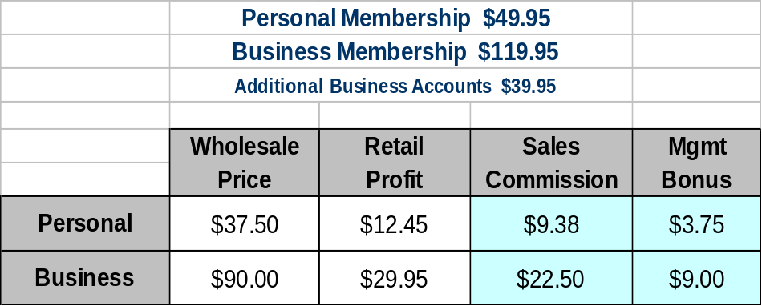Reseller Solution
Suggested Retail Pricing

